Meeting 29
Course / Class #: CECS 4800

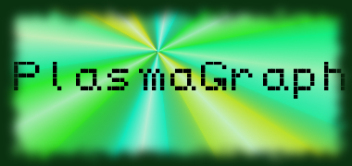
Date: 8 May 2014
Project Name: PlasmaGraph

Has been done:
- Test data files obtained. (Error in creating graph – not translating from header name to variable name correctly in MatlabProcessor's “toDataSet” method.)
- SPMP (r2 complete)
- SDD (Started work on diagrams [Use Case / Requirement sequence diagrams, Package / Class diagrams done, object state machine diagrams and program flow diagram next]; document structure created; Started work on textual explanations.)
- Presentation material cost research.

What will be done:
- Remaining documentation. (SPMP, SRS, SDD)
- Finish presentations, and start gathering materials and designing for project poster.
- Correct bugs with final test data before presenting to Plasma Lab.
- Finish Javadoc.

Materials Used: 2x Computers, Internet connections, Microsoft Visio 2013 / Dia (Diagramming Tools), OpenOffice Writer / Microsoft Word 2013 (Document-writing Tools), Eclipse / NetBeans IDE (Programming Tools).

Group Members: ________________________________
Gerardo A. Navas

________________________________
Daniel Quintini
Professor:

________________________________
Prof. Luis A. Ortiz

